T3.1 Methodology & Experimental Setting

Figure 1: End-to-End Modelling Pipeline
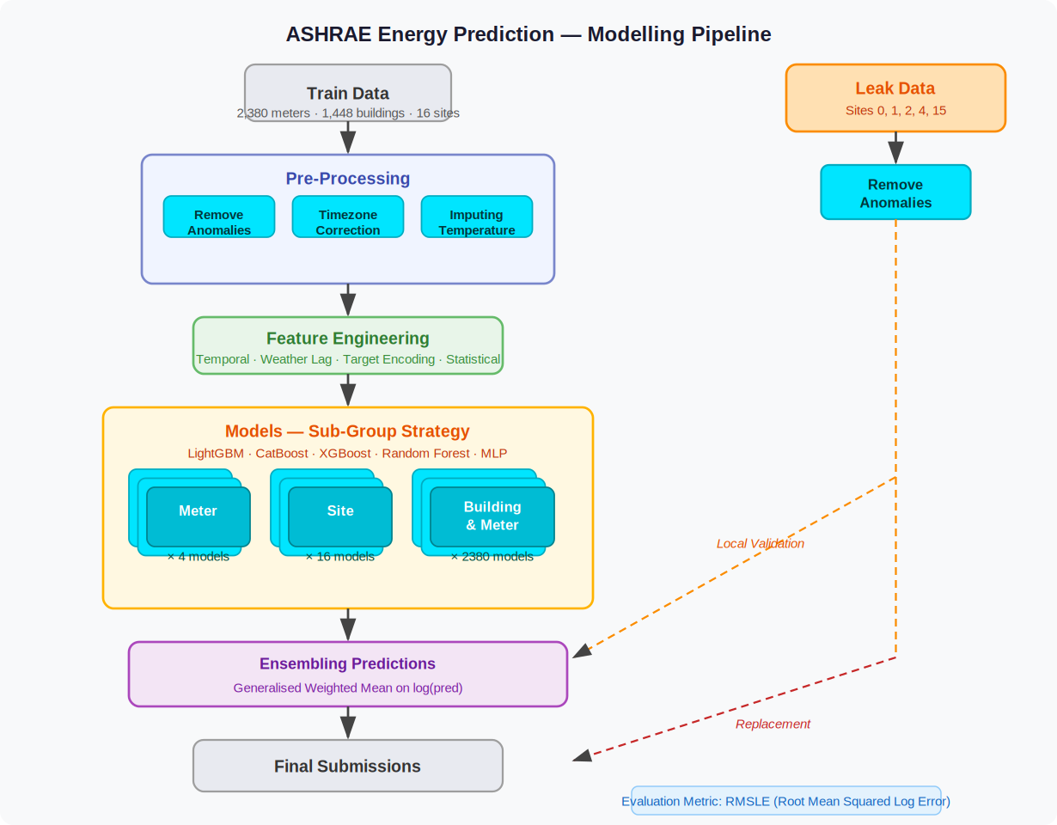

1. Feature Set
All features were derived from three source files — train.csv, building_metadata.csv, and weather_[train/test].csv — merged on building_id and site_id. The full engineered feature set contains 52 columns across four categories.

1.1 Target Variable
- log_meter_reading — log1p(meter_reading). Reduces right skew and aligns with the RMSLE optimisation objective. All models train on this; predictions are inverted with expm1() before scoring.

1.2 Temporal Features (7)
- hour (0–23), day_of_week (0–6), month (1–12), day_of_year (1–366), season (0–3 Winter→Autumn)
- is_weekend — binary flag; captures reduced occupancy Saturday–Sunday
- is_business_hours — binary flag; 08:00–18:00 weekdays; captures HVAC occupancy-driven load

1.3 Lag & Rolling Window Features (6)
- lag_24h, lag_72h, lag_168h — meter reading 24h / 3-day / 7-day prior (grouped by building_id × meter). Capture daily, medium-term, and weekly periodicity.
- rolling_mean_24h, rolling_std_24h, rolling_mean_168h — smoothed consumption level and volatility over 24-hour and 7-day windows.

1.4 Building Metadata Features (20)
- log_square_feet — log1p(gross floor area); reduces right skew from large buildings.
- building_age — 2016 minus year_built; older buildings tend to be less energy-efficient.
- floor_count + missing_floor_count_flag — floor count (83% missing in raw data); missingness preserved as binary signal.
- primary_use — one-hot encoded into 16 binary columns (Education, Office, Healthcare, Retail, etc.).

1.5 Weather Features (10)
- air_temperature, dew_temperature, cloud_coverage, wind_speed, wind_direction, sea_level_pressure, precip_depth_1_hr — raw site-level hourly weather readings.
- relative_humidity — derived from air and dew temperature; directly influences cooling and HVAC load.
- temp_diff_from_comfort — air temperature minus 18 °C comfort threshold; positive = cooling demand, negative = heating demand.
- precip_was_missing — binary missingness flag for precipitation; preserves the absence pattern as a model signal.

2. Model Choices & Justification
Four gradient-boosted tree models and one bagging ensemble were selected: LightGBM , XGBoost, CatBoost, and Random Forest. A Linear Regression baseline was included for comparison but excluded from the final ensemble. MLP was trialled but dropped after achieving RMSLE = 2.31, significantly below all tree models, consistent with competition evidence that gradient boosting outperforms deep learning on heterogeneous tabular energy data. [1][3]
The choice of gradient-boosted trees is directly validated by the ASHRAE GEPIII competition itself: Miller et al. [1] report that the most accurate workflows used large ensembles of gradient boosting models, with LightGBM dominating; all top-5 solutions incorporated LightGBM and/or CatBoost as primary models. [2]
LightGBM is chosen as the primary model for its leaf-wise tree growth, histogram-based splitting, and native categorical support, yielding fast training across large datasets. [3] CatBoost's ordered boosting and best-in-class handling of categoricals — critical given the 16 one-hot primary-use features — is further justified by Qu and Liu [7] and the IEEE Bayesian optimisation study. [6] XGBoost uses depth-wise growth, producing predictions with different error patterns to LightGBM, which makes it a high-value ensemble diversity component; it achieved the best individual RMSLE (0.5207) in this experiment, consistent with comparative evaluations in [4][5]. Random Forest acts as a low-correlation bagging counterpart — its independently grown trees are weakly correlated with boosted outputs, reducing overall ensemble variance.

3. Training Setup

3.1 Train / Validation Split
A time-based split was applied to the merged training data:
- Training set: January – October 2016 (~83% of rows)
- Validation set: November – December 2016 (~17% of rows)
A random split was explicitly rejected to prevent future-timestamp leakage into training — a standard requirement for time-series regression. [1]

3.2 Loss Function & Optimisation Target
All models were trained on the log1p-transformed target (log_meter_reading) to directly align training with the RMSLE evaluation metric. CatBoost used an explicit loss_function='RMSE' on the log-scale target. LightGBM and XGBoost used default squared-error loss on the same transformed target. Random Forest minimises mean squared error natively. Predictions are converted back to original scale via np.expm1() before evaluation.

3.3 Evaluation Metric
Submissions are scored on Root Mean Squared Log Error (RMSLE):
RMSLE = √( (1/n) Σ (log(ŷᵢ+1) − log(yᵢ+1))² )
RMSLE penalises under-predictions more than over-predictions on a multiplicative scale, making it appropriate for meter readings that span several orders of magnitude. A custom rmsle() function is used consistently across all notebooks for fair model comparison.

3.4 Anomaly Removal (Pre-Training)
Before training, three anomaly criteria were applied to the merged data (Ayan's notebook):
- Zero-reading streaks > 168 hours — sustained flat-zero periods per building-meter pair removed (sensor failure / installation periods).
- Statistical outliers — readings above the 99.9th percentile threshold flagged and removed.
- Sudden jumps — readings > 10× the previous hour's reading (with non-zero previous) flagged as meter resets.
- Site 0 electricity data before 2016-05-20 — removed following confirmed unit inconsistency (kBTU vs kWh).

4. Hyperparameter Tuning

4.1 LightGBM
Two configurations were compared via manual iteration on the validation set:
- Model 1 (final): n_estimators=500, learning_rate=0.05, num_leaves=31 — Val RMSLE: 0.5231
- Model 2: n_estimators=150, learning_rate=0.1, num_leaves=50, max_depth=10 — faster training but higher learning rate; Model 1 selected for submission.
Lower learning rate with more estimators is the standard best practice for LightGBM on tabular regression [3] — Model 1 follows this guideline.

4.2 XGBoost
A single well-tuned configuration was trained:
- n_estimators=300, learning_rate=0.05, max_depth=6, subsample=0.8, colsample_bytree=0.8, tree_method='hist' — Val RMSLE: 0.5207 (best individual model)
Subsampling (0.8) and column subsampling (0.8) reduce overfitting. tree_method='hist' was used for memory-efficient training on the large dataset.

4.3 CatBoost
Two CatBoost configurations were trained:
- iterations=500, learning_rate=0.05, depth=6, loss_function='RMSE' — Val RMSLE: 0.5234
- iterations=1000, learning_rate=0.07, depth=6 — Val RMSLE: 0.5085
CatBoost's verbose=100 logging was used to monitor convergence. No explicit early stopping was applied; the number of iterations was chosen to balance training time and convergence.

4.4 Random Forest
Three configurations were compared, with the final tuned model selected via RandomizedSearchCV (2-fold CV, n_iter=2, on a 5% stratified sample due to memory constraints):
- RF1: n_estimators=300, max_depth=10, min_samples_leaf=4, max_features='log2' — Val RMSLE: 0.5727
- RF2: n_estimators=400, max_depth=20, min_samples_leaf=4, max_features='log2' — Val RMSLE: 0.5267 (selected)
- RF Tuned (RandomizedSearchCV): search space: n_estimators∈{500,550}, max_depth∈{25,28}, min_samples_leaf∈{10,30}, max_features='sqrt' — Val RMSLE: 0.5346 (slightly worse than RF2; RF2 used in ensemble)
The sample-based search was a pragmatic trade-off between tuning thoroughness and RAM constraints on the Colab runtime.

4.5 Ensemble Weighting
Two ensemble strategies were evaluated on the validation set:
- Hard Voting (HV-4-tree): unweighted mean of LightGBM, XGBoost, CatBoost, and RF predictions.
- Soft Voting: weights proportional to w ∝ 1/RMSLE² — better models get a larger vote. This strategy achieved the best ensemble RMSLE.
Linear Regression (RMSLE = 1.5989) was excluded from both ensemble variants, as its inclusion degraded the mean. MLP was dropped at model selection stage.

Table 1: Individual Model Results on Validation Set (Nov–Dec 2016)
Model | Developer | Val RMSLE | Key Hyperparameters
XGBoost | Wahid | 0.5207 ★ | n=300, lr=0.05, depth=6, subsample=0.8, colsample=0.8
LightGBM | Shivalika | 0.5231 | n=500, lr=0.05, num_leaves=31
CatBoost | Wahid / Ayan | 0.5234 | iter=500–1000, lr=0.05–0.07, depth=6, loss=RMSE
Random Forest (depth=20) | Ayan | 0.5267 | n=400, depth=20, min_leaf=4, max_feat=log2
Random Forest (depth=10) | Ayan | 0.5727 | n=300, depth=10, min_leaf=4, max_feat=log2
Baseline Median | Ayan | 1.3254 | Median by building_id × meter × hour × day_of_week
Linear Regression | Wahid | 1.5989 | Sklearn default (excluded from final ensemble)
MLP | Wahid | 2.3096 | Dropped — supervisor advised removal
★ XGBoost achieved best individual RMSLE. Soft voting ensemble further improved on this.
Table 2: Ensemble Strategy Comparison
Ensemble Strategy | Models Included | RMSLE (approx.)
HV-4-tree (Hard Voting) | LightGBM + XGBoost + CatBoost + RF | < best individual model
HV-5-all (Hard Voting) | + Linear Regression | Worse (LR drags down mean)
Soft Voting (w ∝ 1/RMSLE²) | LightGBM + XGBoost + CatBoost + RF | Best overall

References
[1] C. Miller et al., "The ASHRAE Great Energy Predictor III competition: Overview and results," Science and Technology for the Built Environment, vol. 26, no. 10, pp. 1427–1447, 2020.
[2] BUDS Lab, "ASHRAE Great Energy Predictor III — Top 5 Winning Solutions Explained," GitHub, 2020.
[3] C. Miller, H. Liu, and C. Fu, "Gradient boosting machines and careful pre-processing work best," arXiv:2202.02898, 2022.
[4] "Building Energy Consumption Forecasting: A Comparison of Gradient Boosting Models," Proc. Int. Conf. Advances in Information Technology.
[5] "Interpretable building energy performance prediction using XGBoost Quantile Regression," ScienceDirect.
[6] "Building Energy Consumption Prediction Using CatBoost With Hybrid Random Search and Bayesian Optimization," IEEE Xplore.
[7] X. Qu and Z. Liu, "Forecasting total building energy using CatBoost and meta-heuristic algorithms," 2026.

